Worship Schedule January 2020

 |  | Jan. 5 | Jan. 12 | Jan. 19 | Jan. 26
Elder |  | Jim Sidle | Ed Zahler | Sam Aikin | Tad Goss
Prayer
Song |  | Terry Davis | William Gooch | Greg Kendall | William Gooch
Leader
Communion |  | Kim Christian | Allen Clark | Chris McGoogan | Mike Villers
Comments
Prayer
Servers | 1 | Ugo Nwakanma | 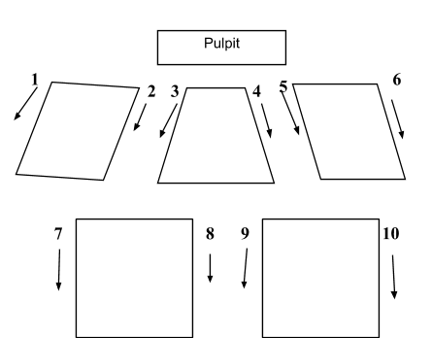
2 trays | 2 | Clarence Morris
3 |  | Jeff Stiner
4 |  | Jeff Wise
2 trays | 5 | David Nelson
 | 6 | Noah Nelson
 | 7 | Calvin Lower
2 trays | 8 | Roger Reisert
2 trays | 9 | Greg Esterman
 | 10 | Nick Autorina
Worship |  |  | David White | David White | David White
Coordinator
Greeters |  | Reisert Team | Northington Team | Christian Team | Ellis Team
Soundboard |  | Jeff Wise | Eric Jordan | Darren Martin | Keith Kalet
PowerPoint |  | William Wise | Daniel White | William Wise | William Wise
Nursery |  | Stacie Northington & Jakia Piner  *Toni Reed | Lois Rhodes & Tayanna Piner  *Jenny Tidwell | Jan Stiner  *Jodi Webb | Julie Tidwell  *Daniel White
*Denotes Toddler Time Teacher
Please check the above schedule for conflicts and let David White know immediately if you cannot serve. His email address is dhwhite@rhs-law.com. It is requested that all participants be at the building by at least 10 minutes before service starts. If you are scheduled to be a Nursery Worker and cannot serve, please find a replacement or contact Laura White at 770-356-3783. If you are taking count for Bible Classes, the book for recording attendance is in behind the counter in the foyer. Thank you for serving!!

