Worship Schedule November 2019

 |  | Nov. 3 | Nov. 10 | Nov. 17 | Nov. 24
Elder |  | Fred Norton | Jim Sidle | Milt Shymlock | Ed Zahler
Prayer
Song |  | Greg Kendall | William Gooch | William Gooch | Terry Davis
Leader
Communion |  | Steve Curlee | Bo Bolick | Milt Shymlock | James Armour
Comments
Scripture/ |  | Jeff Stiner | Matthew Scott/  Bill Ellis | Ellis Reed/  John Cheshier | Liam Carey/Mike Villers
Prayer
Servers | 1 | Gary Scott | 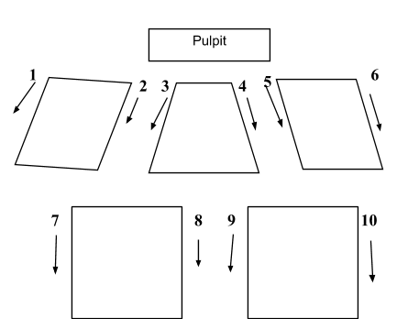
2 trays | 2 | David Scott
3 |  | Randy Carwile
4 |  | Noah Goss
2 trays | 5 | Kim Christian
 | 6 | Mark Trainer
 | 7 | Jason Trainer
2 trays | 8 | Allen Clark
2 trays | 9 | Jim Shortal
 | 10 | Calvin Lower
Worship |  | Doug Carey | David White | David White | David White
Coordinator
Greeters |  | Northington Team | Christian Team | Ellis Team | West Team
Soundboard |  | Keith Kalet | Keith Kalet | Eric Jordan | Keith Kalet
PowerPoint |  | William Wise | William Wise | Daniel White | Keith Kalet
Nursery |  | Shelly & Ava Carey  *Jenny Tidwell | Kristen & Jakia Piner  *Jodi Webb | Denise Ellis & Tayanna Piner  *Daniel White | Rhonda Hawkins  *Laura White
*Denotes Toddler Time Teacher
Please check the above schedule for conflicts and let David White know immediately if you cannot serve. His email address is dhwhite@rhs-law.com. It is requested that all participants be at the building by at least 10 minutes before service starts. If you are scheduled to be a Nursery Worker and cannot serve, please find a replacement or contact Laura White at 770-356-3783. If you are taking count for Bible Classes, the book for recording attendance is in behind the counter in the foyer. Thank you for serving!!

